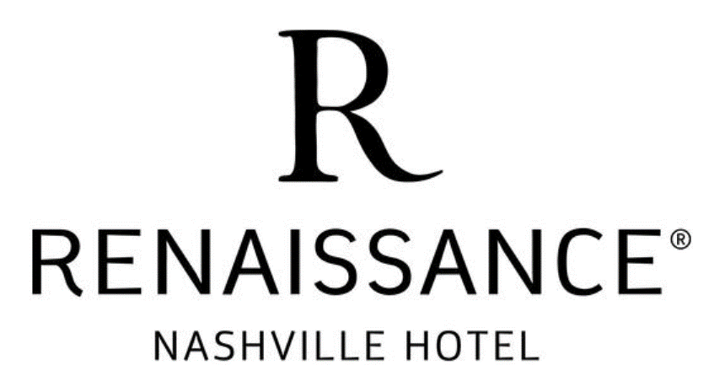

07/22/2025
Dear Guest:
The primary parking garage utilized by the Renaissance Nashville Hotel located at 151 6th Ave North has been temporarily closed with an unknown reopen date.

During this time our valet stand is open with limited capacity.

While we apologize for this inconvenience, there are many options that are within blocks of our hotel, including the Fifth + Broadway Garage located at 598 Broadway, Nashville 37203

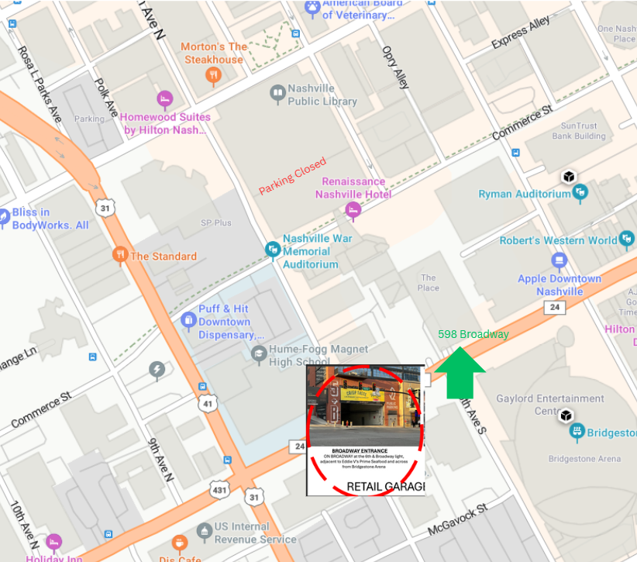

For other options withing walking distance, please visit:
https://nashvilledowntown.com/get-around/nashville-parking/garages

For guests coming from Nashville International Airport (BNA) or for day events, we strongly encourage you to use ridesharing services to get to the hotel.

We look forward to Welcoming you to Music City,
Renaissance Nashville Hotel Events Team

